Anna and Her Basketball Adventure

A group of teenage boys was playing basketball on the court at the park. The basketball court didn’t have a fence around it. If one of the boys missed the basket, someone had to catch the basketball quickly so it wouldn’t bounce too far away.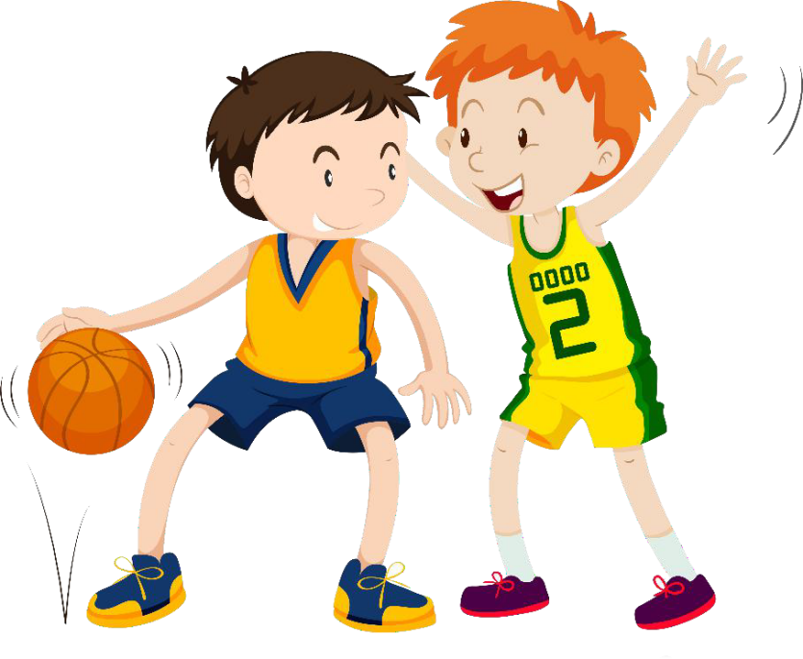 One of the boys was showing off, and he tossed the ball with all of his strength from the one end of the court toward the basket on the other end. The ball was flying like a rocket over the heads of all of the other boys. Then it kept right on flying. It flew straight over the basket and out into the field.

Anna was sitting at the end of the field near the pond watching the ducks swim. She heard some yelling and turned to see a big orange object headed her way. The yelling was coming from the teenage boys.

“Stop the ball,” one of them shouted.

The ball landed a few feet away from her. It started rolling and was heading right for the pond. The ducks saw it nearing and started flapping their wings wildly in fear. Anna saved the ducks and the ball. She threw her arms out to stop the ball just as it was about to splash into the water.

“Bring it over here,” called one of the boys.

Anna shyly walked the ball over to the court. She was only in grade school and older kids made her nervous. They ended up being very nice though.

“Thanks, kiddo,” they all said at once.

“Can I try a shot?” Anna asked the boys.

The boys said, “Sure,” but they all chuckled because Anna was so much younger and shorter than them. They didn’t think she qould be able to toss the ball even halfway to the basket.

Anna took the ball and stood at the free throw line. She concentrared hard and focused on the basket. Then she gave it her best shot. The boys watched with amazement as the ball whoosed straight into the basket. Anna smiled as the boys all cheered loudly for her.